Lab - Switch Security Configuration

Topology
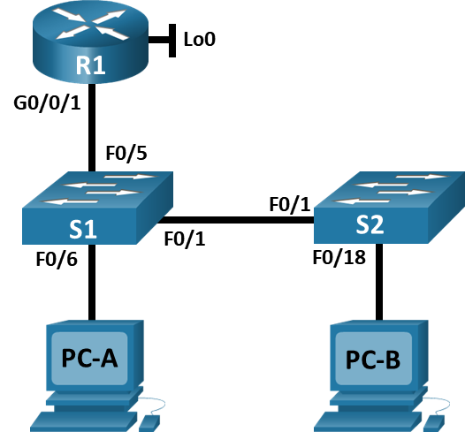

Addressing Table
Device | Interface / VLAN | IP Address | Subnet Mask
R1 | G0/0/1 | 192.168.10.1 | 255.255.255.0
R1 | Loopback 0 | 10.10.1.1 | 255.255.255.0
S1 | VLAN 10 | 192.168.10.201 | 255.255.255.0
S2 | VLAN 10 | 192.168.10.202 | 255.255.255.0
PC – A | NIC | DHCP | 255.255.255.0
PC – B | NIC | DHCP | 255.255.255.0

Objectives
Part 1: Configure the Network Devices.
- Cable the network.
- Configure R1.
- Configure and verify basic switch settings.
Part 2: Configure VLANs on Switches.
- Configure VLAN 10.
- Configure the SVI for VLAN 10.
- Configure VLAN 333 with the name Native on S1 and S2.
- Configure VLAN 999 with the name ParkingLot on S1 and S2.
Part 3: Configure Switch Security.
- Implement 802.1Q trunking.
- Configure access ports.
- Secure and disable unused switchports.
- Document and implement port security features.
- Implement DHCP snooping security.
- Implement PortFast and BPDU guard.
- Verify end-to-end-connectivity.

Background / Scenario
This is a comprehensive lab to review previously covered Layer 2 security features.
Note: The routers used with CCNA hands-on labs are Cisco 4221 with Cisco IOS XE Release 16.9.3 (universalk9 image). The switches used in the labs are Cisco Catalyst 2960s with Cisco IOS Release 15.0(2) (lanbasek9 image). Other routers, switches, and Cisco IOS versions can be used. Depending on the model and Cisco IOS version, the commands available and the output produced might vary from what is shown in the labs. Refer to the Router Interface Summary Table at the end of the lab for the correct interface identifiers.
Note: Make sure that the switches have been erased and have no startup configurations. If you are unsure, contact your instructor.

Required Resources
- 1 Router (Cisco 4221 with Cisco IOS XE Release 16.9.3 universal image or comparable)
- 2 Switches (Cisco 2960 with Cisco IOS Release 15.0(2) lanbasek9 image or comparable)
- 2 PCs (Windows with a terminal emulation program, such as Tera Term)
- Console cables to configure the Cisco IOS devices via the console ports
- Ethernet cables as shown in the topology

Instructions

Configure the Network Devices.

Cable the network.
- Cable the network as shown in the topology.
- Initialize the devices.
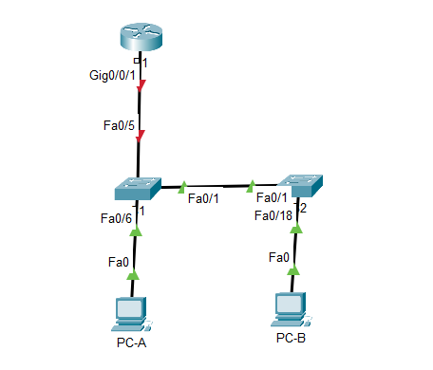

Configure R1.
      - Load the following configuration script on R1.
Open configuration window
enable
configure terminal
hostname R1
no ip domain lookup
ip dhcp excluded-address 192.168.10.1 192.168.10.9
ip dhcp excluded-address 192.168.10.201 192.168.10.202
!
ip dhcp pool Students
network 192.168.10.0 255.255.255.0
default-router 192.168.10.1
domain-name CCNA2.Lab-11.6.1
!
interface Loopback0
ip address 10.10.1.1 255.255.255.0
!
interface GigabitEthernet0/0/1
description Link to S1 Port 5
ip address 192.168.10.1 255.255.255.0
no shutdown
!
ip dhcp relay information trust-all
line con 0
logging synchronous
exec-timeout 0 0
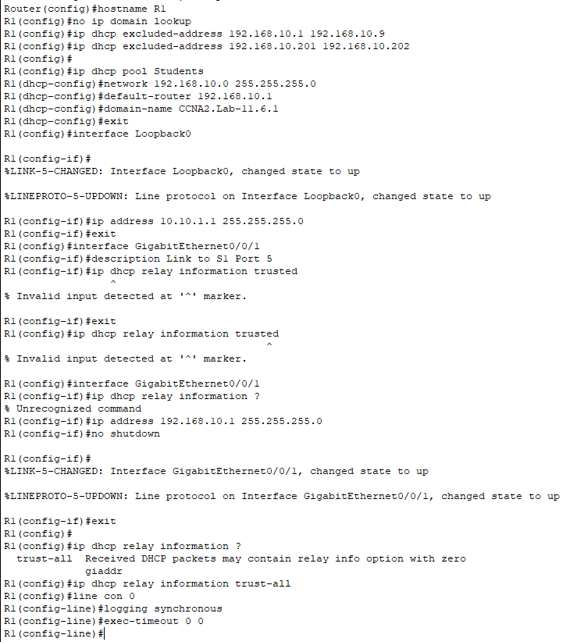

      - Verify the running-configuration on R1 using the following command:
R1# show ip interface brief
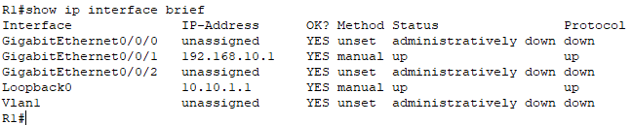

- Verify IP addressing and interfaces are in an up / up state (troubleshoot as necessary).
Close configuration window

Configure and verify basic switch settings.
      - Configure the hostname for switches S1 and S2.
Open configuration window
Open configuration window
      - Prevent unwanted DNS lookups on both switches.
      - Configure interface descriptions for the ports that are in use in S1 and S2.
      - Set the default-gateway for the Management VLAN to 192.168.10.1 on both switches.
S1 | 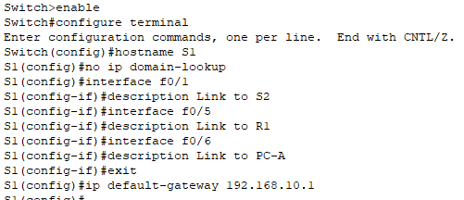  Switch> enable  Switch# configure terminal  Switch(config)# hostname S1  S1(config)# no ip domain-lookup  S1(config)# interface f0/1  S1(config-if)# description Link to S2  S1(config–if)# interface f0/5  S1(config-if)# description Link to R1  S1(config–if)# interface f0/6  S1(config-if)# description Link to PC-A  S1(config)# ip default-gateway 192.168.10.1
S2 | 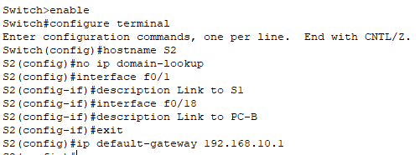  Switch> enable  Switch# configure terminal  Switch(config)# hostname S2  S2(config)# no ip domain-lookup  S2(config)# interface f0/1  S2(config-if)# description Link to S1  S2(config–if)# interface f0/18  S2(config-if)# description Link to PC-B  S2(config)# ip default-gateway 192.168.10.1

Configure VLANs on Switches.

Configure VLAN 10.
Add VLAN 10 to S1 and S2 and name the VLAN Management.
S1 | 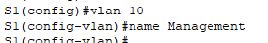  S1(config)#vlan 10  S1(config-vlan)#name Management  S1(config-vlan)#EXIT
S2 | 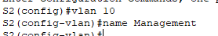  S2(config)#vlan 10  S2(config-vlan)#name Management  S2(config-vlan)#EXIT

Configure the SVI for VLAN 10.
Configure the IP address according to the Addressing Table for SVI for VLAN 10 on S1 and S2. Enable the SVI interfaces and provide a description for the interface.
S1 | 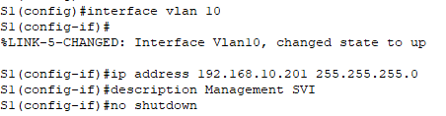  S1(config)#interface vlan 10  S1(config-if)#ip address 192.168.10.201 255.255.255.0  S1(config-if)#description Management SVI  S1(config-if)#no shutdown
S2 | 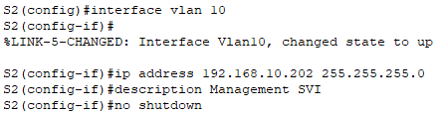  S2(config)#interface vlan 10  S2(config-if)#ip address 192.168.10.202 255.255.255.0  S2(config-if)#description Management SVI  S2(config-if)#no shutdown

Configure VLAN 333 with the name Native on S1 and S2.
S1 | 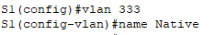  S1(config)#vlan 333  S1(config-vlan)#name Native
S2 | 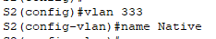  S2(config)#vlan 333  S2(config-vlan)#name Native

Configure VLAN 999 with the name ParkingLot on S1 and S2.
S1 | 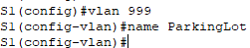  S1(config)#vlan 999  S1(config-vlan)#name ParkingLot
S2 | 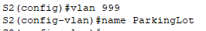  S2(config)#vlan 999  S2(config-vlan)#name ParkingLot

Configure Switch Security.

Implement 802.1Q trunking.
      - On both switches, configure trunking on F0/1 to use VLAN 333 as the native VLAN.
S1 | 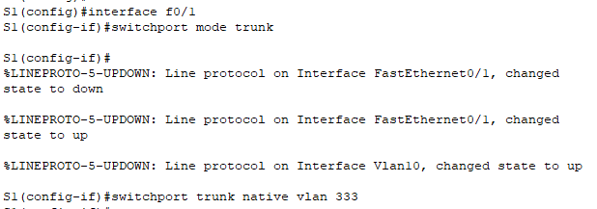  S1(config)#interface f0/1  S1(config-if)#switchport mode trunk  S1(config-if)#switchport trunk native vlan 333
S2 | 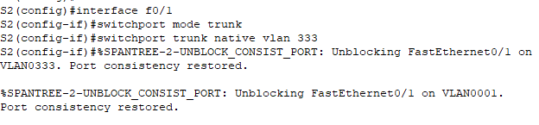  S2(config)#interface f0/1  S2(config-if)#switchport mode trunk  S2(config-if)#switchport trunk native vlan 333

      - Verify that trunking is configured on both switches.
S1# show interface trunk

Port Mode Encapsulation Status Native vlan
Fa0/1 on 802.1q trunking 333

Port Vlans allowed on trunk
Fa0/1 1-4094

Port Vlans allowed and active in management domain
Fa0/1 1,10,333,999

Port Vlans in spanning tree forwarding state and not pruned
Fa0/1 1,10,333,999

S2# show interface trunk

Port Mode Encapsulation Status Native vlan
Fa0/1 on 802.1q trunking 333

Port Vlans allowed on trunk
Fa0/1 1-4094

Port Vlans allowed and active in management domain
Fa0/1 1,10,333,999

Port Vlans in spanning tree forwarding state and not pruned
Fa0/1 1,10,333,999

Ensure PCA and PCB can get the IP address from R1. R1 provide DHCP services to clients. Do not proceed if cannot get DHCP IP address.
See diagrams below:
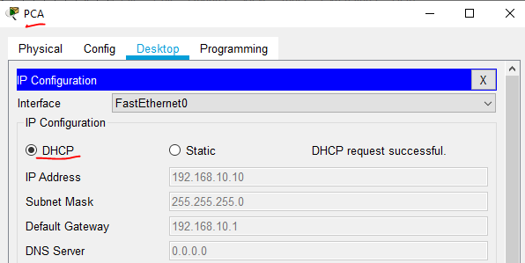
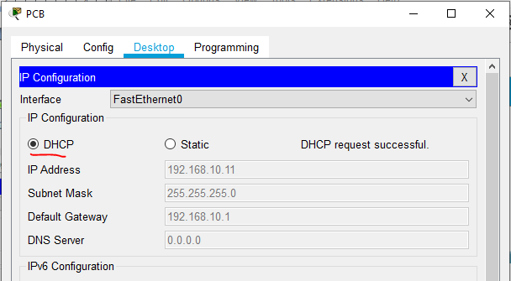
S1 | 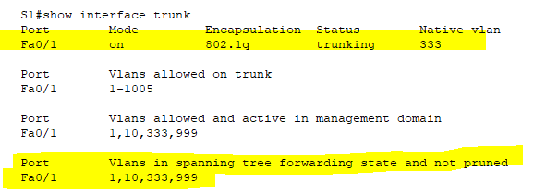
S2 | 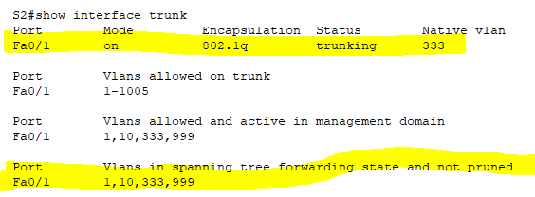

      - Disable DTP negotiation on F0/1 on S1 and S2.
S1 | 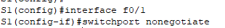  S1(config)#interface f0/1  S1(config-if)#switchport nonegotiate
S2 | 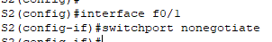  S2(config)#interface f0/1  S2(config-if)#switchport nonegotiate

      - Verify with the show interfaces command.
S1# show interfaces f0/1 switchport | include Negotiation
Negotiation of Trunking: Off

S2# show interfaces f0/1 switchport | include Negotiation
Negotiation of Trunking: Off
S1 | 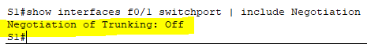
S2 | 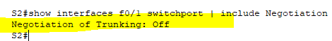

Configure access ports.
      - On S1, configure F0/5 and F0/6 as access ports that are associated with VLAN 10.
S1 | 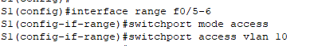  S1(config)#interface range f0/5-6  S1(config-if-range)#switchport mode access  S1(config-if-range)#switchport access vlan 10

      - On S2, configure F0/18 as an access port that is associated with VLAN 10.
S2 | 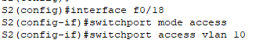  S2(config)#interface f0/18  S2(config-if)#switchport mode access  S2(config-if)#switchport access vlan 10

Secure and disable unused switchports.
      - On S1 and S2, move the unused ports from VLAN 1 to VLAN 999 and disable the unused ports.
S1 | 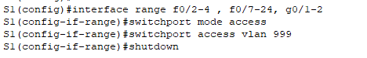  S1(config)#interface range f0/2-4 , f0/7-24, g0/1-2  S1(config-if-range)#switchport mode access  S1(config-if-range)#switchport access vlan 999  S1(config-if-range)#shutdown
S2 | 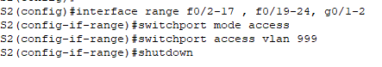  S2(config)#interface range f0/2-17 , f0/19-24, g0/1-2  S2(config-if-range)#switchport mode access  S2(config-if-range)#switchport access vlan 999  S2(config-if-range)#shutdown

      - Verify that unused ports are disabled and associated with VLAN 999 by issuing the show command.
S1# show interfaces status

Port Name Status Vlan Duplex Speed Type
Fa0/1 Link to S2 connected trunk a-full a-100 10/100BaseTX
Fa0/2 disabled 999 auto auto 10/100BaseTX
Fa0/3 disabled 999 auto auto 10/100BaseTX
Fa0/4 disabled 999 auto auto 10/100BaseTX
Fa0/5 Link to R1 connected 10 a-full a-100 10/100BaseTX
Fa0/6 Link to PC-A connected 10 a-full a-100 10/100BaseTX
Fa0/7 disabled 999 auto auto 10/100BaseTX
Fa0/8 disabled 999 auto auto 10/100BaseTX
Fa0/9 disabled 999 auto auto 10/100BaseTX
Fa0/10 disabled 999 auto auto 10/100BaseTX
<output omitted>
S2# show interfaces status

Port Name Status Vlan Duplex Speed Type
Fa0/1 Link to S1 connected trunk a-full a-100 10/100BaseTX
Fa0/2 disabled 999 auto auto 10/100BaseTX
Fa0/3 disabled 999 auto auto 10/100BaseTX
<output omitted>
Fa0/14 disabled 999 auto auto 10/100BaseTX
Fa0/15 disabled 999 auto auto 10/100BaseTX
Fa0/16 disabled 999 auto auto 10/100BaseTX
Fa0/17 disabled 999 auto auto 10/100BaseTX
Fa0/18 Link to PC-B connected 10 a-full a-100 10/100BaseTX
Fa0/19 disabled 999 auto auto 10/100BaseTX
Fa0/20 disabled 999 auto auto 10/100BaseTX
Fa0/21 disabled 999 auto auto 10/100BaseTX
Fa0/22 disabled 999 auto auto 10/100BaseTX
Fa0/23 disabled 999 auto auto 10/100BaseTX
Fa0/24 disabled 999 auto auto 10/100BaseTX
Gi0/1 disabled 999 auto auto 10/100/1000BaseTX
Gi0/2 disabled 999 auto auto 10/100/1000BaseTX
S1 | 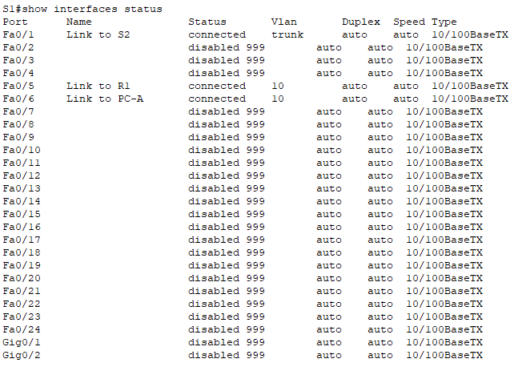
S2 | 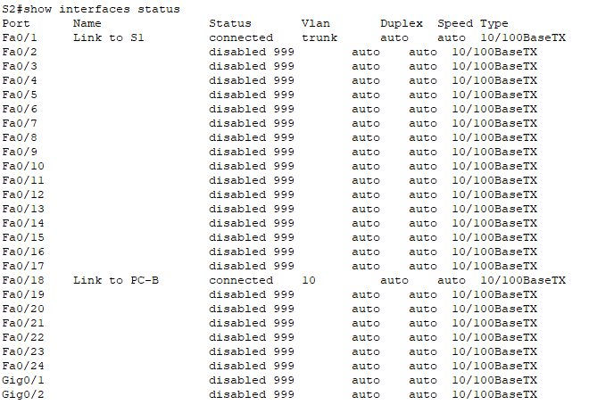

Document and implement port security features.
The interfaces F0/6 on S1 and F0/18 on S2 are configured as access ports. In this step, you will also configure port security on these two access ports.
      - On S1, issue the show port-security interface f0/6 command to display the default port security settings for interface F0/6. Record your answers in the table below.
Default Port Security Configuration
Feature | Default Setting
Port Security | Disabled
Maximum number of MAC addresses | 1
Violation Mode | Shutdown
Aging Time | 0 mins
Aging Type | Absolute
Secure Static Address Aging | Disabled
Sticky MAC Address | 0
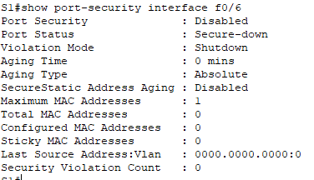
      - On S1, enable port security on F0/6 with the following settings:
- Maximum number of MAC addresses: 3
- Violation type: restrict
- Aging time: 60 min
- Aging type: inactivity
S1 | 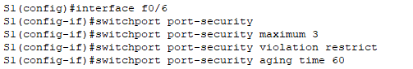  S1(config)#interface f0/6  S1(config-if)#switchport port-security  S1(config-if)#switchport port-security maximum 3  S1(config-if)#switchport port-security violation restrict  S1(config-if)#switchport port-security aging time 60  S1(config-if)#switchport port-security aging type inactivity

      - Verify port security on S1 F0/6.
S1# show port-security interface f0/6
Port Security : Enabled
Port Status : Secure-up
Violation Mode : Restrict
Aging Time : 60 mins
Aging Type : Inactivity
SecureStatic Address Aging : Disabled
Maximum MAC Addresses : 3
Total MAC Addresses : 1
Configured MAC Addresses : 0
Sticky MAC Addresses : 0
Last Source Address:Vlan : 0022.5646.3411:10
Security Violation Count : 0

S1# show port-security address
Secure Mac Address Table
-----------------------------------------------------------------------------
Vlan Mac Address Type Ports Remaining Age
(mins)
---- ----------- ---- ----- -------------
10 0022.5646.3411 SecureDynamic Fa0/6 60 (I)
-----------------------------------------------------------------------------
Total Addresses in System (excluding one mac per port) : 0
Max Addresses limit in System (excluding one mac per port) : 8192
      - Enable port security for F0/18 on S2. Configure the port to add MAC addresses learned on the port automatically to the running configuration.
S2 | 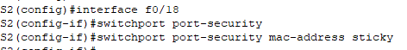  S2(config)#interface f0/18  S2(config-if)#switchport port-security  S2(config-if)#switchport port-security mac-address sticky

      - Configure the following port security settings on S2 F/18:
- Maximum number of MAC addresses: 2
- Violation type: Protect
- Aging time: 60 min
S2 | 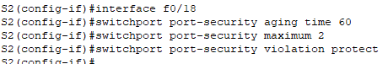  S2(config-if)#interface f0/18  S2(config-if)#switchport port-security aging time 60  S2(config-if)#switchport port-security maximum 2  S2(config-if)#switchport port-security violation protect

      - Verify port security on S2 F0/18.
S2# show port-security interface f0/18
Port Security : Enabled
Port Status : Secure-up
Violation Mode : Protect
Aging Time : 60 mins
Aging Type : Absolute
SecureStatic Address Aging : Disabled
Maximum MAC Addresses : 2
Total MAC Addresses : 1
Configured MAC Addresses : 0
Sticky MAC Addresses : 0
Last Source Address:Vlan : 0022.5646.3413:10
Security Violation Count : 0

S2# show port-security address
Secure Mac Address Table
-----------------------------------------------------------------------------
Vlan Mac Address Type Ports Remaining Age
(mins)
---- ----------- ---- ----- -------------
10 0022.5646.3413 SecureSticky Fa0/18 -
-----------------------------------------------------------------------------
Total Addresses in System (excluding one mac per port) : 0
Max Addresses limit in System (excluding one mac per port) : 8192

Implement DHCP snooping security.
      - On S2, enable DHCP snooping and configure DHCP snooping on VLAN 10.
S2 | 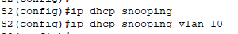  S2(config)#ip dhcp snooping  S2(config)#ip dhcp snooping vlan 10

      - Configure the trunk port on S2 as a trusted port.
S2 | 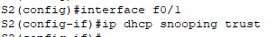  S2(config)#interface f0/1  S2(config-if)#ip dhcp snooping trust

      - Limit the untrusted port, F18 on S2, to five DHCP packets per second.
S2 | 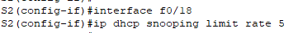  S2(config-if)#interface f0/18  S2(config-if)#ip dhcp snooping limit rate 5

      - Verify DHCP Snooping on S2.
S2# show ip dhcp snooping
Switch DHCP snooping is enabled
DHCP snooping is configured on following VLANs:
10
DHCP snooping is operational on following VLANs:
10
DHCP snooping is configured on the following L3 Interfaces:
Insertion of option 82 is enabled
circuit-id default format: vlan-mod-port
remote-id: 0cd9.96d2.3f80 (MAC)
Option 82 on untrusted port is not allowed
Verification of hwaddr field is enabled
Verification of giaddr field is enabled
DHCP snooping trust/rate is configured on the following Interfaces:

Interface Trusted Allow option Rate limit (pps)
----------------------- ------- ------------ ----------------
FastEthernet0/1 yes yes unlimited
Custom circuit-ids:
FastEthernet0/18 no no 5
Custom circuit-ids:
      - From the command prompt on PC-B, release and then renew the IP address.
C:\Users\Student> ipconfig /release
C:\Users\Student> ipconfig /renew

PT cannot support dhcp snooping commands.PCB will get 169.254.198.65.
PCB supposed to get 192.168.10.11.
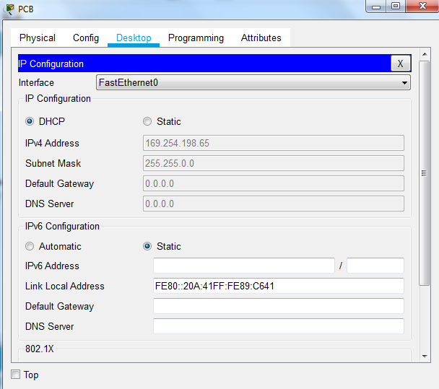

Add this command in R1, so PCB can get IP address.
R1(config)#ip dhcp relay information trust-all
PCB click “Static” then “DHCP” to obtain the leased address.
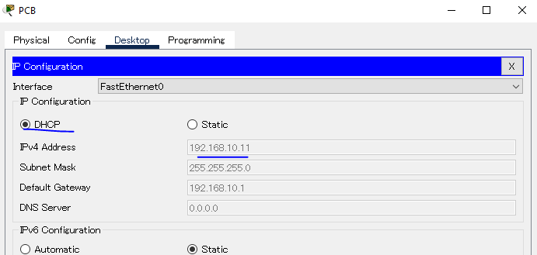
      - Verify the DHCP snooping binding using the show ip dhcp snooping binding command.
S2# show ip dhcp snooping binding
MacAddress IpAddress Lease(sec) Type VLAN Interface
------------------ --------------- ---------- ------------- ---- --------------------
00:50:56:90:D0:8E 192.168.10.11 86213 dhcp-snooping 10 FastEthernet0/18
Total number of bindings: 1

Implement PortFast and BPDU guard.
      - Configure PortFast on all the access ports that are in use on both switches.
S1 | 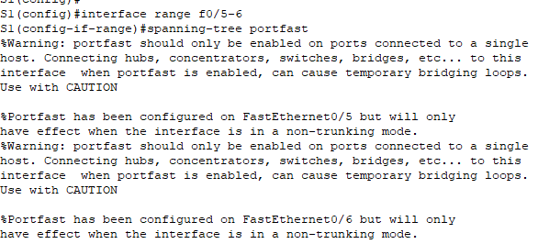  S1(config)#interface range f0/5-6  S1(config-if-range)#spanning-tree portfast
S2 | 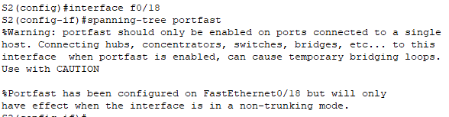  S2(config)#interface f0/18  S2(config-if)#spanning-tree portfast

      - Enable BPDU guard on S1 and S2 VLAN 10 access ports connected to PC-A and PC-B.
S1 | 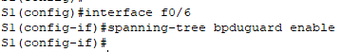  S1(config)#interface f0/6  S1(config-if)#spanning-tree bpduguard enable
S2 | 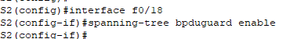  S2(config)#interface f0/18  S2(config-if)#spanning-tree bpduguard enable

      - Verify that BPDU guard and PortFast are enabled on the appropriate ports.
S1# show spanning-tree interface f0/6 detail
Port 8 (FastEthernet0/6) of VLAN0010 is designated forwarding
Port path cost 19, Port priority 128, Port Identifier 128.6.
<output omitted for brevity>
Number of transitions to forwarding state: 1
The port is in the portfast mode
Link type is point-to-point by default
Bpdu guard is enabled
BPDU: sent 128, received 0

Verify end-to-end connectivity.
Verify PING connectivity between all devices in the IP Addressing Table. If the pings fail, you may need to disable the firewall on the PC hosts.
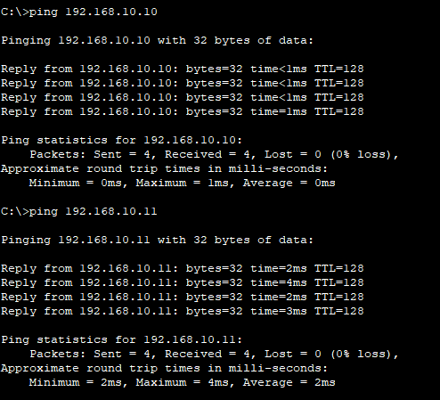

Close configuration window

Reflection Questions
  - In reference to Port Security on S2, why is there no timer value for the remaining age in minutes when sticky learning was configured?
Because S2 does not support port security aging for sticky security addresses.

  - In reference to Port Security on S2, if you load the running-config script on S2, why will PC-B on port 18 never get an IP address via DHCP?
Because port security is only set up for two MAC addresses, and port 18 has two sticky MAC addresses bound to that port.
  - In reference to Port Security, what is the difference between the absolute aging type and inactivity aging type?
Starting with absolute type, all secure addresses on this port expire exactly after the specified time has elapsed.
For the inactive type, the secure address on the port is removed only if there is no data traffic from the secure source address for a specified period of time.
End of Document

